Earth: An Introduction to Physical Geology, 12e (Tarbuck)
Chapter 1 An Introduction to Geology

1.1 Multiple-Choice Questions

1) Which of the following is a natural disaster?
A) A hurricane forming in the ocean
B) A landslide striking a city
C) A volcano erupting on an uninhabited island
D) An earthquake occurring in the desert
Answer: B
Diff: 1
Bloom's Taxonomy: Remembering/Understanding
Global Sci Out: 5 & 7
Section: 1.1 - Geology: The Science of the Earth
Focus/Concepts: 1.1
ESLI LO: 8.1 - Natural hazards result from natural Earth processes.

2) Which culture recorded the earliest writings about topics such as fossils, earthquakes, and gemstones?
A) Roman Empire
B) Renaissance Europe
C) Ancient China
D) Ancient Greece
Answer: D
Diff: 1
Bloom's Taxonomy: Remembering/Understanding
Global Sci Out: 7
Section: 1.2 - The Development of Geology
Focus/Concepts: 1.2
ESLI LO: 7.2 - Geology affects the distribution and development of human populations.

3) Which of the following is not a geologic hazard?
A) Use of poor construction materials resulting in a cracked foundation
B) Volcanic eruptions sending lava flows toward a city
C) Deforestation on a floodplain increasing the severity of river floods
D) Climate change leading to sea-level rise
Answer: A
Diff: 2
Bloom's Taxonomy: Remembering/Understanding
Global Sci Out: 5 & 7
Section: 1.1 - Geology: The Science of the Earth
Focus/Concepts: 1.1
ESLI LO: 8.1 - Natural hazards result from natural Earth processes.
4) The principle of ________ states that the physical, chemical, and biological processes at work shaping the Earth today have also operated in the geologic past.
A) catastrophism
B) plate tectonics
C) plutonism
D) Uniformitarianism
Answer: D
Diff: 1
Bloom's Taxonomy: Remembering/Understanding
Global Sci Out: 7
Section: 1.2 - The Development of Geology
Focus/Concepts: 1.2
ESLI LO: 1.5 - Earth scientists use their understanding of the past to forecast Earth's future.

5) What is the accepted age of the Earth?
A) 10,000 years
B) 1 million years
C) 4.6 million years
D) 4.6 billion years
Answer: C
Diff: 1
Bloom's Taxonomy: Remembering/Understanding
Global Sci Out: 7
Section: 1.2 - The Development of Geology
Focus/Concepts: 1.2
ESLI LO: 2.2 - Our Solar System formed from a vast cloud of gas and dust 4.6 billion years ago.

6) ________ was an important eighteenth-century geologist who developed the concept of Uniformitarianism to explain the slow, steady changes responsible for shaping the Earth.
A) Charles Lyell
B) Isaac Newton
C) James Hutton
D) Charles Darwin
Answer: C
Diff: 1
Bloom's Taxonomy: Remembering/Understanding
Global Sci Out: 7
Section: 1.2 - The Development of Geology
Focus/Concepts: 1.2
ESLI LO: 1.5 - Earth scientists use their understanding of the past to forecast Earth's future.

7) Which of the following is the definition for a scientific hypothesis?
A) The gathering of data through observations
B) A tentative explanation used to explain observed activities
C) A well-tested and widely accepted view that explains observable facts
D) An educated guess
Answer: B
Diff: 1
Bloom's Taxonomy: Remembering/Understanding
Global Sci Out: 1
Section: 1.3 - The Nature of Scientific Inquiry
Focus/Concepts: 1.3
ESLI LO: 1.3 - Earth science investigations take many different forms.
8) Which of the following is the definition of a scientific theory?
A) The gathering of data through observations
B) A tentative explanation used to explain observed activities
C) A well-tested and widely accepted view that explains observable facts
D) An educated guess
Answer: C
Diff: 1
Bloom's Taxonomy: Remembering/Understanding
Global Sci Out: 1
Section: 1.3 - The Nature of Scientific Inquiry
Focus/Concepts: 1.3
ESLI LO: 1.3 - Earth science investigations take many different forms.

9) Science uses observations of phenomena in order to make interpretations. Which of the following is an observation?
A) A fold is visible in an outcrop.
B) The fold was created by pressure.
C) Pressure was applied slowly to fold the rock.
D) Heat was applied to soften the rock.
Answer: A
Diff: 1
Bloom's Taxonomy: Remembering/Understanding
Global Sci Out: 1
Section: 1.3 - The Nature of Scientific Inquiry
Focus/Concepts: 1.3
ESLI LO: 1.3 - Earth science investigations take many different forms.

10) What percentage of the Earth is covered by oceans?
A) 50%
B) 17%
C) 80%
D) 71%
Answer: D
Diff: 1
Bloom's Taxonomy: Remembering/Understanding
Global Sci Out: 7
Section: 1.4 - Earth as a System
Focus/Concepts: 1.4
ESLI LO: 5.1 - Water is found everywhere on Earth, from the heights of the atmosphere to the depths of the mantle.

11) Which of the following is not one of the roles of the atmosphere?
A) Energy exchanges between the surface and outer space, creating weather and climate
B) Lessening the effects of weathering on the geosphere
C) Protection from ultraviolet radiation and the intensity of the Sun
D) Providing air for respiratory processes in the biosphere
Answer: B
Diff: 1
Bloom's Taxonomy: Remembering/Understanding
Global Sci Out: 2 & 7
Section: 1.4 - Earth as a System
Focus/Concepts: 1.4
ESLI LO: 3.1 - The four major systems of Earth are the geosphere, hydrosphere, atmosphere, and biosphere.
12) Which of the four spheres of Earth is the most extensive?
A) Geosphere
B) Atmosphere
C) Hydrosphere
D) Biosphere
Answer: A
Diff: 1
Bloom's Taxonomy: Remembering/Understanding
Global Sci Out: 2
Section: 1.4 - Earth as a System
Focus/Concepts: 1.4
ESLI LO: 3.1 - The four major systems of Earth are the geosphere, hydrosphere, atmosphere, and biosphere.

13) What is the scientifically accepted age of the formation of the universe?
A) 4.6 billion years
B) 10 billion years
C) 13.7 billion years
D) 8.7 billion years
Answer: C
Diff: 1
Bloom's Taxonomy: Remembering/Understanding
Global Sci Out: 7
Section: 1.5 - Origin and Early Evolution of Earth
Focus/Concepts: 1.5
ESLI LO: 2.2 - Our Solar System formed from a vast cloud of gas and dust 4.6 billion years ago.

14) The debris from the Big Bang was made almost entirely of ________.
A) oxygen and silicon
B) hydrogen and helium
C) iron and nickel
D) carbon and nitrogen
Answer: B
Diff: 1
Bloom's Taxonomy: Remembering/Understanding
Global Sci Out: 7
Section: 1.5 - Origin and Early Evolution of Earth
Focus/Concepts: 1.5
ESLI LO: 2.2 - Our Solar System formed from a vast cloud of gas and dust 4.6 billion years ago.

15) What caused our solar nebula to contract and spin, eventually creating the planets?
A) Gravitational interactions between particles
B) Gravitational attraction from black holes
C) Nuclear fusion joining atomic particles
D) Solar winds from nearby stars
Answer: A
Diff: 1
Bloom's Taxonomy: Remembering/Understanding
Global Sci Out: 7
Section: 1.5 - Origin and Early Evolution of Earth
Focus/Concepts: 1.5
ESLI LO: 2.2 - Our Solar System formed from a vast cloud of gas and dust 4.6 billion years ago.
16) Which of the following Earth materials can be used to make interpretations about the nature and composition of the interior of the Earth?
A) Meteorites
B) Diamond-bearing kimberlite pipes
C) Slivers of crustal and mantle rocks exposed at the surface
D) Meteorites, kimberlite pipes, and slivers of crustal and mantle rocks
E) Groundwater and vapors in geothermal systems
Answer: D
Diff: 1
Bloom's Taxonomy: Remembering/Understanding
Global Sci Out: 2 & 7
Section: 1.5 - Origin and Early Evolution of Earth
Focus/Concepts: 1.5
ESLI LO: 2.3 - Earth was formed from the accumulation of dust and gas, and from multiple collisions of smaller planetary bodies.

17) What is the definition of planetary differentiation?
A) Separation of materials based on density
B) Categorization based on chemical formulas
C) Mixing of materials to produce a new compound
D) Divisions of planets based on constituent materials
Answer: A
Diff: 1
Bloom's Taxonomy: Remembering/Understanding
Global Sci Out: 7
Section: 1.5 - Origin and Early Evolution of Earth
Focus/Concepts: 1.5
ESLI LO: 4.2 - Earth, like other planets, is still cooling, though radioactive decay continuously generates heat.

18) Because the early Earth was a large sphere of magma, the earliest rocks that formed here were recycled into the mantle long ago. What is the age of the oldest radiometrically dated rocks discovered on the planet? (Or, what is the age of the oldest remaining rocks on Earth?)
A) 6,000 years old
B) 4.6 million years old
C) 4 billion years old
D) 4.6 billion years old
Answer: C
Diff: 1
Bloom's Taxonomy: Remembering/Understanding
Global Sci Out: 7
Section: 1.5 - Origin and Early Evolution of Earth
Focus/Concepts: 1.5
ESLI LO: 2.4 - Earth's crust has two distinct types: continental and oceanic.
19) What property of the crust allowed it to form as the exterior of Earth?
A) Magma at the surface cooled and crystallized before anything in the interior.
B) Materials that make up the crust are less dense and rose to the top.
C) Churning and upheaval in the interior thrust crustal rocks toward the surface.
D) Meteorites impacting Earth deposited this material at the surface.
Answer: B
Diff: 2
Bloom's Taxonomy: Remembering/Understanding
Global Sci Out: 2
Section: 1.6 - Earth's Internal Structure
Focus/Concepts: 1.6
ESLI LO: 2.4 - Earth's crust has two distinct types: continental and oceanic.

20) What provides us with the most information about the interior of the Earth?
A) Borehole data
B) Erupted materials
C) Satellite imagery
D) Seismic energy waves
Answer: D
Diff: 1
Bloom's Taxonomy: Remembering/Understanding
Global Sci Out: 7
Section: 1.6 - Earth's Internal Structure
Focus/Concepts: 1.6
ESLI LO: 1.4 - Earth scientists must use indirect methods to examine and understand the structure, composition, and dynamics of Earth's interior.

21) A research team is studying the velocity of seismic waves in various types of rock. Using explosives, they create small explosions to study how fast the energy waves will travel. Using the velocity data below, infer which rocks are higher in density and which are lower in density. Which rock or rocks have the highest density?

Rock A: 7 km/s
Rock B: 5.9 km/s
Rock C: 7.2 km/s
Rock D: 6.1 km/s
Rock E: 6.25 km/s

A) Rock C
B) Rocks B & D
C) Rocks B, D, & E
D) Rocks A & C
Answer: D
Diff: 3
Bloom's Taxonomy: Applying/Analyzing
Global Sci Out: 2
Section: 1.6 - Earth's Internal Structure
Focus/Concepts: 1.6
ESLI LO: 1.4 - Earth scientists must use indirect methods to examine and understand the structure, composition, and dynamics of Earth's interior.
22) If the temperature in the Earth generally increases with depth, how is it possible that the inner core is a solid?
A) Temperatures increase to a certain point before leveling off below the melting point of the core.
B) The pressures in the core are immense and keep it in a solid state in spite of the temperature.
C) Earth's interior does not reach temperatures high enough to melt the material of the inner core.
D) The inner core is shedding the heat so quickly that melting does not have time to occur.
Answer: B
Diff: 2
Bloom's Taxonomy: Remembering/Understanding
Global Sci Out: 2 & 7
Section: 1.6 - Earth's Internal Structure
Focus/Concepts: 1.6
ESLI LO: 4.2 - Earth, like other planets, is still cooling, though radioactive decay continuously generates heat.

23) Which layer of the Earth is the thinnest?
A) Crust
B) Mantle
C) Outer Core
D) Inner Core
Answer: A
Diff: 1
Bloom's Taxonomy: Remembering/Understanding
Global Sci Out: 7
Section: 1.6 - Earth's Internal Structure
Focus/Concepts: 1.6
ESLI LO: 2.4 - Earth's crust has two distinct types: continental and oceanic.

24) Which layer of the Earth is the thickest?
A) Crust
B) Mantle
C) Outer core
D) Inner core
Answer: B
Diff: 1
Bloom's Taxonomy: Remembering/Understanding
Global Sci Out: 7
Section: 1.6 - Earth's Internal Structure
Focus/Concepts: 1.6
ESLI LO: 2.4 - Earth's crust has two distinct types: continental and oceanic.
25) What is the asthenosphere?
A) A portion of the atmosphere that blocks UV radiation
B) A soft, low-velocity layer in the upper mantle
C) The transition zone between the mantle and the outer core
D) The portion of the hydrologic cycle that describes how plants contribute their respiration
Answer: B
Diff: 1
Bloom's Taxonomy: Remembering/Understanding
Global Sci Out: 7
Section: 1.6 - Earth's Internal Structure
Focus/Concepts: 1.6
ESLI LO: 4.4 - Earth's tectonic plates consist of the rock crust and uppermost mantle, and move slowly with respect to one another.

26) The ________ is a layer of liquid nickel and iron believed to be responsible for generating the Earth's magnetic field.
A) Crust
B) Mantle
C) Outer Core
D) Inner Core
Answer: C
Diff: 1
Bloom's Taxonomy: Remembering/Understanding
Global Sci Out: 7
Section: 1.6 - Earth's Internal Structure
Focus/Concepts: 1.6
ESLI LO: 4.2 - Earth, like other planets, is still cooling, though radioactive decay continuously generates heat.

27) What is the texture of a rock?
A) How the rock feels to the touch
B) The composition of minerals that make up the rock
C) The shape of the rock
D) The size, shape, and/or arrangement of minerals in a rock
Answer: D
Diff: 1
Bloom's Taxonomy: Remembering/Understanding
Global Sci Out: 7
Section: 1.7 - Rocks and the Rock Cycle
Focus/Concepts: 1.7
ESLI LO: 4.6 - Earth materials take many different forms as they cycle through the geosphere.

28) What is the definition of lithification?
A) The breakdown of materials due to exposure to the elements
B) The process by which sediments are made into rock
C) The transportation of sediments from their place of origin
D) The crystallization of minerals through cooling
Answer: C
Diff: 1
Bloom's Taxonomy: Remembering/Understanding
Global Sci Out: 7
Section: 1.7 - Rocks and the Rock Cycle
Focus/Concepts: 1.7
ESLI LO: 4.6 - Earth materials take many different forms as they cycle through the geosphere.
29) Which characteristics are used to determine the processes that created a rock?
A) Heat and pressure
B) Texture and composition
C) Size and shape
D) Color and texture
Answer: B
Diff: 1
Bloom's Taxonomy: Remembering/Understanding
Global Sci Out: 7
Section: 1.7 - Rocks and the Rock Cycle
Focus/Concepts: 1.7
ESLI LO: 4.6 - Earth materials take many different forms as they cycle through the geosphere.

30) The geologic rock cycle presents an orderly transition from igneous to sedimentary to metamorphic rocks. However, there are also some alternative transitions that bypass part of the rock cycle. Which of the following is the best example of one of those bypasses?
A) Igneous rocks are weathered and eroded to become sediments.
B) Metamorphic rocks are melted to become magma.
C) Magma cools and crystallizes to form igneous rocks.
D) Sedimentary rocks are weathered into sediments, which become lithified into sedimentary rocks.
Answer: D
Diff: 1
Bloom's Taxonomy: Remembering/Understanding
Global Sci Out: 7
Section: 1.7 - Rocks and the Rock Cycle
Focus/Concepts: 1.7
ESLI LO: 4.6 - Earth materials take many different forms as they cycle through the geosphere.

31) If the age of a mountain range is inversely proportional to its height, in what two regions are the youngest mountain ranges found today?
A) The circum-Atlantic belt and southern Europe/Asia
B) Western South America and the Appalachians of North America
C) The circum-Pacific belt and southern Europe/Asia
D) Scandinavia and Eastern Africa
Answer: C
Diff: 1
Bloom's Taxonomy: Remembering/Understanding
Global Sci Out: 7
Section: 1.8 - The Face of the Earth
Focus/Concepts: 1.8
ESLI LO: 4.5 - Many active geologic processes occur at plate boundaries.
32) A ________ is a part of the craton that is covered by a thin covering of sedimentary rocks.
A) shield
B) continental shelf
C) platform
D) plateau
Answer: C
Diff: 1
Bloom's Taxonomy: Remembering/Understanding
Global Sci Out: 7
Section: 1.8 - The Face of the Earth
Focus/Concepts: 1.8
ESLI LO: 2.4 - Earth's crust has two distinct types: continental and oceanic.

33) Continents have a density of ________ and are made of ________ rock.
A) 1.9 g/cm3; sandstone
B) 4.5 g/cm3; gneiss
C) 3.0 g/cm3; basalt
D) 2.7 g/cm3; granite
Answer: D
Diff: 1
Bloom's Taxonomy: Remembering/Understanding
Global Sci Out: 7
Section: 1.8 - The Face of the Earth
Focus/Concepts: 1.8
ESLI LO: 2.4 - Earth's crust has two distinct types: continental and oceanic.

34) The rock that makes up ocean basins has a density of ________ and is made of ________.
A) 1.9 g/cm3; sandstone
B) 4.5 g/cm3; gneiss
C) 3.0 g/cm3; basalt
D) 2.7 g/cm3; granite
Answer: C
Diff: 1
Bloom's Taxonomy: Remembering/Understanding
Global Sci Out: 7
Section: 1.8 - The Face of the Earth
Focus/Concepts: 1.8
ESLI LO: 2.4 - Earth's crust has two distinct types: continental and oceanic.
35) Which of the following rocks will be most buoyant on the Earth's mantle?

Rock A: Density 1.4 g/cm3
Rock B: Density 5.6 g/cm3
Rock C: Density 5.1 g/cm3
Rock D: Density 2.7 g/cm3

A) Rock A
B) Rock B
C) Rock C
D) Rock D
Answer: A
Diff: 1
Bloom's Taxonomy: Remembering/Understanding
Global Sci Out: 7
Section: 1.8 - The Face of the Earth
Focus/Concepts: 1.8
ESLI LO: 2.4 - Earth's crust has two distinct types: continental and oceanic.

36) The ________ is a flooded margin of the continent.
A) continental shelf
B) deep-ocean floor
C) continental slope
D) continental rise
Answer: A
Diff: 1
Bloom's Taxonomy: Remembering/Understanding
Global Sci Out: 3 & 7
Section: 1.8 - The Face of the Earth
Focus/Concepts: 1.8
ESLI LO: 3.1 - The four major systems of Earth are the geosphere, hydrosphere, atmosphere, and biosphere.

37) Which physical feature represents the true transition from the continent to the ocean basin?
A) The shoreline
B) The continental shelf
C) The continental slope
D) The continental rise
E) The deep-ocean floor
Answer: C
Diff: 1
Bloom's Taxonomy: Remembering/Understanding
Global Sci Out: 3 & 7
Section: 1.8 - The Face of the Earth
Focus/Concepts: 1.8
ESLI LO: 3.1 - The four major systems of Earth are the geosphere, hydrosphere, atmosphere, and biosphere.
38) Along which features might one expect to see a deep-ocean trench?
A) Abyssal plains
B) Mountain ranges
C) Oceanic ridges
D) Seamounts
Answer: B
Diff: 1
Bloom's Taxonomy: Remembering/Understanding
Global Sci Out: 3 & 7
Section: 1.8 - The Face of the Earth
Focus/Concepts: 1.8
ESLI LO: 3.1 - The four major systems of Earth are the geosphere, hydrosphere, atmosphere, and biosphere.

39) ________ describes Earth's origins and its development through time.
A) Natural hazards
B) Physical geology
C) Historical geology
D) Uniformitarianism
Answer: C
Diff: 1
Bloom's Taxonomy: Remembering/Understanding
Global Sci Out: 7
Section: 1.1 - Geology: The Science of the Earth
Focus/Concepts: 1.1
ESLI LO: 1.5 - Earth scientists use their understanding of the past to forecast Earth's future.

40) Archbishop James Ussher used the Bible to construct a chronology to date the creation of the Earth to ________.
A) 1776 A.D
B) 46,000 B.C.E
C) 79 A.D
D) 4004 B.C.E
Answer: D
Diff: 1
Bloom's Taxonomy: Remembering/Understanding
Global Sci Out: 7
Section: 1.2 - The Development of Geology
Focus/Concepts: 1.2
ESLI LO: 1.5 - Earth scientists use their understanding of the past to forecast Earth's future.

41) The majority of water in the hydrosphere is found in which feature?
A) Rivers
B) Oceans
C) Water vapor
D) Glaciers
Answer: B
Diff: 2
Bloom's Taxonomy: Remembering/Understanding
Global Sci Out: 2
Section: 1.4 - Earth as a System
Focus/Concepts: 1.4
ESLI LO: 5.5 - Earth's water cycles among the reservoirs of the atmosphere, streams, lakes, ocean, glaciers, groundwater, and deep interior of the planet.
42) What is the relationship between the four spheres of Earth?
A) The four spheres operate independently from each other.
B) The geosphere and the hydrosphere overlap, but the atmosphere and biosphere operate independently.
C) The four spheres overlap and interact with each other.
D) The biosphere and hydrosphere interact with each other, whereas the geosphere and atmosphere are part of a separate system.
Answer: C
Diff: 2
Bloom's Taxonomy: Remembering/Understanding
Global Sci Out: 2
Section: 1.4 - Earth as a System
Focus/Concepts: 1.4
ESLI LO: 3.1 - The four major systems of Earth are the geosphere, hydrosphere, atmosphere, and biosphere.

43) The interior of the Earth is divided into roughly spherical layers of differing ________.
A) density
B) temperature
C) pressure
D) magma
Answer: A
Diff: 1
Bloom's Taxonomy: Remembering/Understanding
Global Sci Out: 7
Section: 1.5 - Origin and Early Evolution of Earth
Focus/Concepts: 1.5
ESLI LO: 2.3 - Earth was formed from the accumulation of dust and gas, and from multiple collisions of smaller planetary bodies.

44) Which of these statements best describes the lithosphere?
A) The lithosphere is the layer in the interior of the Earth that is just below the crust.
B) The lithosphere is composed of the crust and the rigid part of the upper mantle.
C) The lithosphere is a low-density part of the upper mantle.
D) The lithosphere consists solely of the crust.
Answer: B
Diff: 1
Bloom's Taxonomy: Remembering/Understanding
Global Sci Out: 2
Section: 1.6 - Earth's Internal Structure
Focus/Concepts: 1.6
ESLI LO: 4.5 - Many active geologic processes occur at plate boundaries.
45) A ________ is the interior of a continental mass that has been relatively undisturbed for the last 600 million years.
A) mountain belt
B) margin
C) craton
D) shield
Answer: C
Diff: 1
Bloom's Taxonomy: Remembering/Understanding
Global Sci Out: 7
Section: 1.8 - The Face of the Earth
Focus/Concepts: 1.8
ESLI LO: 2.4 - Earth's crust has two distinct types: continental and oceanic.

46) ________ is the concept that describes how the Earth was shaped by sudden, violent events over a short period of time.
A) Uniformitarianism
B) Catastrophism
C) Neptunism
D) Differentiation
Answer: B
Diff: 1
Bloom's Taxonomy: Remembering/Understanding
Global Sci Out: 7
Section: 1.2 - The Development of Geology
Focus/Concepts: 1.2
ESLI LO: 1.5 - Earth scientists use their understanding of the past to forecast Earth's future.

1.2 True/False Questions

1) Geologic hazards are natural processes.
Answer: TRUE
Diff: 1
Bloom's Taxonomy: Remembering/Understanding
Global Sci Out: 7
Section: 1.1 - Geology: The Science of the Earth
Focus/Concepts: 1.1
ESLI LO: 8.1 - Natural hazards result from natural Earth processes.

2) Before a hypothesis can become an accepted part of scientific knowledge, it must pass objective testing and analysis.
Answer: TRUE
Diff: 2
Bloom's Taxonomy: Remembering/Understanding
Global Sci Out: 1
Section: 1.3 - The Nature of Scientific Inquiry
Focus/Concepts: 1.3
ESLI LO: 1.3 - Earth science investigations take many different forms.
3) A hypothesis can never be changed or modified.
Answer: FALSE
Diff: 2
Bloom's Taxonomy: Remembering/Understanding
Global Sci Out: 1
Section: 1.3 - The Nature of Scientific Inquiry
Focus/Concepts: 1.3
ESLI LO: 1.3 - Earth science investigations take many different forms.

4) Both energy and matter will flow in and out of an open system.
Answer: TRUE
Diff: 1
Bloom's Taxonomy: Remembering/Understanding
Global Sci Out: 2
Section: 1.4 - Earth as a System
Focus/Concepts: 1.4
ESLI LO: 3.2 - All Earth processes are the result of energy flowing and mass cycling within and between Earth's systems.

5) Crystallization of molten rock can produce metamorphic rocks.
Answer: FALSE
Diff: 1
Bloom's Taxonomy: Remembering/Understanding
Global Sci Out: 7
Section: 1.7 - Rocks and the Rock Cycle
Focus/Concepts: 1.7
ESLI LO: 4.6 - Earth materials take many different forms as they cycle through the geosphere.

6) External processes driven by solar energy can create the materials necessary for sedimentary rocks.
Answer: TRUE
Diff: 2
Bloom's Taxonomy: Remembering/Understanding
Global Sci Out: 7
Section: 1.7 - Rocks and the Rock Cycle
Focus/Concepts: 1.7
ESLI LO: 3.3 - Earth exchanges mass and energy with the rest of the solar system.
1.3 Matching Questions

Match the steps of the scientific method with the appropriate order from first to last.

A) Observations and experiments are developed to test the hypothesis.
B) Data is collected that relates to the question.
C) Hypotheses are rejected, modified, or accepted.
D) Results are shared with the scientific community.
E) A question is proposed about the natural world.
F) Questions are posed and a hypothesis is developed.

1) First
Diff: 2
Bloom's Taxonomy: Remembering/Understanding
Global Sci Out: 1
Section: 1.3 - The Nature of Scientific Inquiry
Focus/Concepts: 1.3
ESLI LO: 1.3 - Earth science investigations take many different forms.

2) Second
Diff: 2
Bloom's Taxonomy: Remembering/Understanding
Global Sci Out: 1
Section: 1.3 - The Nature of Scientific Inquiry
Focus/Concepts: 1.3
ESLI LO: 1.3 - Earth science investigations take many different forms.

3) Third
Diff: 2
Bloom's Taxonomy: Remembering/Understanding
Global Sci Out: 1
Section: 1.3 - The Nature of Scientific Inquiry
Focus/Concepts: 1.3
ESLI LO: 1.3 - Earth science investigations take many different forms.

4) Fourth
Diff: 2
Bloom's Taxonomy: Remembering/Understanding
Global Sci Out: 1
Section: 1.3 - The Nature of Scientific Inquiry
Focus/Concepts: 1.3
ESLI LO: 1.3 - Earth science investigations take many different forms.
5) Fifth
Diff: 2
Bloom's Taxonomy: Remembering/Understanding
Global Sci Out: 1
Section: 1.3 - The Nature of Scientific Inquiry
Focus/Concepts: 1.3
ESLI LO: 1.3 - Earth science investigations take many different forms.

6) Sixth
Diff: 2
Bloom's Taxonomy: Remembering/Understanding
Global Sci Out: 1
Section: 1.3 - The Nature of Scientific Inquiry
Focus/Concepts: 1.3
ESLI LO: 1.3 - Earth science investigations take many different forms.

Answers: 1) E 2) B 3) F 4) A 5) C 6) D

Match the sphere of the Earth with the correct definition.

A) Gaseous envelope around the planet
B) The solid Earth
C) Water portion of the planet
D) All life on the planet

7) Hydrosphere
Diff: 1
Bloom's Taxonomy: Remembering/Understanding
Global Sci Out: 7
Section: 1.4 - Earth as a System
Focus/Concepts: 1.4
ESLI LO: 3.1 - The four major systems of Earth are the geosphere, hydrosphere, atmosphere, and biosphere.

8) Biosphere
Diff: 1
Bloom's Taxonomy: Remembering/Understanding
Global Sci Out: 7
Section: 1.4 - Earth as a System
Focus/Concepts: 1.4
ESLI LO: 3.1 - The four major systems of Earth are the geosphere, hydrosphere, atmosphere, and biosphere.
9) Atmosphere
Diff: 1
Bloom's Taxonomy: Remembering/Understanding
Global Sci Out: 7
Section: 1.4 - Earth as a System
Focus/Concepts: 1.4
ESLI LO: 3.1 - The four major systems of Earth are the geosphere, hydrosphere, atmosphere, and biosphere.

10) Geosphere
Diff: 1
Bloom's Taxonomy: Remembering/Understanding
Global Sci Out: 7
Section: 1.4 - Earth as a System
Focus/Concepts: 1.4
ESLI LO: 3.1 - The four major systems of Earth are the geosphere, hydrosphere, atmosphere, and biosphere.

Answers: 7) C 8) D 9) A 10) B

Match the events leading up to the formation of the early Earth in order.

A) Formation of proto-planets.
B) Formation of solar nebula.
C) Contraction of interstellar materials.
D) Nuclear fission lights up Sun.

11) First
Diff: 1
Bloom's Taxonomy: Remembering/Understanding
Global Sci Out: 7
Section: 1.5 - Origin and Early Evolution of Earth
Focus/Concepts: 1.5
ESLI LO: 2.2 - Our Solar System formed from a vast cloud of gas and dust 4.6 billion years ago.

12) Second
Diff: 1
Bloom's Taxonomy: Remembering/Understanding
Global Sci Out: 7
Section: 1.5 - Origin and Early Evolution of Earth
Focus/Concepts: 1.5
ESLI LO: 2.2 - Our Solar System formed from a vast cloud of gas and dust 4.6 billion years ago.
13) Third
Diff: 1
Bloom's Taxonomy: Remembering/Understanding
Global Sci Out: 7
Section: 1.5 - Origin and Early Evolution of Earth
Focus/Concepts: 1.5
ESLI LO: 2.2 - Our Solar System formed from a vast cloud of gas and dust 4.6 billion years ago.

14) Fourth
Diff: 1
Bloom's Taxonomy: Remembering/Understanding
Global Sci Out: 7
Section: 1.5 - Origin and Early Evolution of Earth
Focus/Concepts: 1.5
ESLI LO: 2.2 - Our Solar System formed from a vast cloud of gas and dust 4.6 billion years ago.

Answers: 11) C 12) B 13) D 14) A
Match the collection of rocks below into the three categories of rocks.

A) Slate, schist, quartzite, phyllite
B) Granite, gabbro, rhyolite, basalt
C) Limestone, conglomerate, arkose, dolomite

15) Igneous rocks
Diff: 2
Bloom's Taxonomy: Applying/Analyzing
Global Sci Out: 2
Section: 1.7 - Rocks and the Rock Cycle
Focus/Concepts: 1.7
ESLI LO: 4.6 - Earth materials take many different forms as they cycle through the geosphere.

16) Sedimentary rocks
Diff: 2
Bloom's Taxonomy: Applying/Analyzing
Global Sci Out: 2
Section: 1.7 - Rocks and the Rock Cycle
Focus/Concepts: 1.7
ESLI LO: 4.6 - Earth materials take many different forms as they cycle through the geosphere.

17) Metamorphic rocks
Diff: 2
Bloom's Taxonomy: Applying/Analyzing
Global Sci Out: 2
Section: 1.7 - Rocks and the Rock Cycle
Focus/Concepts: 1.7
ESLI LO: 4.6 - Earth materials take many different forms as they cycle through the geosphere.

Answers: 15) B 16) C 17) A
Match the rock type with the correct definition.

A) Rocks that form from the crystallization of molten material
B) Rocks that form when a pre-existing rock is altered due to heat and pressure
C) Rocks that form from pre-existing materials going through lithification

18) Igneous
Diff: 1
Bloom's Taxonomy: Remembering/Understanding
Global Sci Out: 7
Section: 1.7 - Rocks and the Rock Cycle
Focus/Concepts: 1.7
ESLI LO: 4.6 - Earth materials take many different forms as they cycle through the geosphere.

19) Sedimentary
Diff: 1
Bloom's Taxonomy: Remembering/Understanding
Global Sci Out: 7
Section: 1.7 - Rocks and the Rock Cycle
Focus/Concepts: 1.7
ESLI LO: 4.6 - Earth materials take many different forms as they cycle through the geosphere.

20) Metamorphic
Diff: 1
Bloom's Taxonomy: Remembering/Understanding
Global Sci Out: 7
Section: 1.7 - Rocks and the Rock Cycle
Focus/Concepts: 1.7
ESLI LO: 4.6 - Earth materials take many different forms as they cycle through the geosphere.

Answers: 18) A 19) C 20) B
1.4 Essay Questions

1) Explain how an increasing population and urban sprawl make people more vulnerable to natural disasters. Give three reasons.
Answer: Answers will vary, but those listed in the text include:
Coastal wetlands and dunes, which protect coastal cities from storms, are destroyed. Sea-level rise will inundate coastal areas. Urban areas in seismic and/or volcanic areas will concentrate a large number of people in the path of these hazards. As construction commences, poor construction practices or inappropriate land use may concentrate people in vulnerable sites. Urbanization can change the magnitude and frequency of flooding of rivers. Students should be able to list three reasons for full credit.
Diff: 3
Bloom's Taxonomy: Remembering/Understanding
Global Sci Out: 5 & 8
Section: 1.1 - Geology: The Science of the Earth
Focus/Concepts: 1.1
ESLI LO: 9.5 - Human activities alter the natural land surface.

2) In the sixteenth and seventeenth centuries, the doctrine of catastrophism was used to describe how the Earth had been shaped quickly by fast, violent catastrophes and was therefore very young. In the eighteenth century, James Hutton developed the principle of uniformitarianism, which stated that the Earth was shaped by small, gradual changes occurring over a long period of time, making the Earth much older. Which view (if either) is correct, and why?
Answer: The Earth is shaped by catastrophic events such as earthquakes and floods, which cause major changes in a short period of time. However, the Earth is also shaped by small, gradual changes such as stream deposition and weathering, which may only show measurable change after several decades or centuries. In reality, both views are correct.
Diff: 3
Bloom's Taxonomy: Evaluating/Creating
Global Sci Out: 7 & 8
Section: 1.2 - The Development of Geology
Focus/Concepts: 1.2
ESLI LO: 1.5 - Earth scientists use their understanding of the past to forecast Earth's future.

3) What is a scientific theory? Explain how a scientific theory differs from the way most nonscientists use the word theory in everyday language.
Answer: A scientific theory is a well-tested and widely accepted view that the scientific community agrees best explains observable facts. The more familiar usage of theory in everyday language usually refers to an educated guess.
Diff: 2
Bloom's Taxonomy: Remembering/Understanding
Global Sci Out: 1 & 8
Section: 1.3 - The Nature of Scientific Inquiry
Focus/Concepts: 1.3
ESLI LO: 1.3 - Earth science investigations take many different forms.
4) Explain the difference between a scientific hypothesis and a scientific theory.
Answer: A scientific hypothesis is an untested explanation developed to try to explain a set of observations. A scientific theory is a well-tested and widely accepted view that best explains the observable facts.
Diff: 2
Bloom's Taxonomy: Remembering/Understanding
Global Sci Out: 1 & 8
Section: 1.3 - The Nature of Scientific Inquiry
Focus/Concepts: 1.3
ESLI LO: 1.3 - Earth science investigations take many different forms.

5) Changes in one part of the Earth system can influence processes in other parts of the system. Sometimes these changes can be minor, but sometimes they can be severe. How might a change in the hydrosphere affect the geosphere and the biosphere?
Answer: A decrease in the amount of precipitation would affect the biosphere through drought and climate change. The geosphere would be affected because there would be less water for weathering and erosion of sediments.
Diff: 3
Bloom's Taxonomy: Remembering/Understanding
Global Sci Out: 7 & 8
Section: 1.4 - Earth as a System
Focus/Concepts: 1.4
ESLI LO: 3.7 - Changes in part of one system can cause new changes to that system or to other systems, often in surprising and complex ways.

6) On May 18, 1980, the volcano Mount St. Helens in Washington State erupted, devastating life and landscape for over 200 mi2 through ash falls, lahars, and other pyroclastic deposits. Explain how the eruption (part of the geosphere) affected the atmosphere and hydrosphere.
Answer: The eruption ejected large quantities of ash and gases into the atmosphere and significant geologic debris into the nearby lakes and rivers (hydrosphere).
Diff: 3
Bloom's Taxonomy: Applying/Analyzing
Global Sci Out: 2 & 8
Section: 1.4 - Earth as a System
Focus/Concepts: 1.4
ESLI LO: 3.7 - Changes in part of one system can cause new changes to that system or to other systems, often in surprising and complex ways.

7) Compare and contrast the thickness of the material that makes up ocean basins and continents and how they sit on the mantle. (Which one sits higher on the mantle and why?)
Answer: Continental material is thicker (up to 70 km) but, in spite of that, sits higher on the mantle because it is less dense (2.7 g/cm3). Oceanic material is thinner (averaging at 7 km), but denser (3.0 g/cm3).
Diff: 3
Bloom's Taxonomy: Applying/Analyzing
Global Sci Out: 2 & 8
Section: 1.8 - The Face of the Earth
Focus/Concepts: 1.8
ESLI LO: 2.4 - Earth's crust has two distinct types: continental and oceanic.
8) In the seventeenth century, Archbishop James Ussher of Ireland used the Bible to calculate that the Earth was created in 4004 b.c.e. Imagine you could take Archbishop Ussher to Niagara Falls. Although Niagara Falls is located on the border between the United States and Canada today, it was located several kilometers to the north at the Niagara Escarpment and is eroding southward. Let's assume the rate of erosion is 50 cm/yr. Assuming the distance from the Niagara Escarpment to Niagara Falls is 11 km, use the equation Rate = Distance/Time to calculate how long it would have taken to erode from the Escarpment to the current location of the falls. How would this calculation compare with Archbishop Ussher's assessment of the age of the Earth?
Answer: Rewriting the Rate Equation so that Time = Distance/Rate:
11 km = 1,100,000 cm
Time = 1,100,000 cm/50 cm per year = 22,000 years
It took 22,000 years to erode the material, not to mention the fact that it would take time to deposit the rock before the river could erode it. These numbers, supported by geologic evidence, prove Ussher's age of the Earth is too young.
Diff: 2
Bloom's Taxonomy: Applying/Analyzing
Global Sci Out: 2 & 4
Section: 1.2 - The Development of Geology
Focus/Concepts: 1.2
ESLI LO: 1.3 - Earth science investigations take many different forms.

9) The science of geology borrows principles and techniques from other sciences in order to determine what happened in the past. Which three sciences contribute knowledge and principles that geologists use to understand the natural world?
Answer: Biology, physics, and chemistry
Diff: 1
Bloom's Taxonomy: Remembering/Understanding
Global Sci Out: 7 & 8
Section: 1.1 - Geology: The Science of the Earth
Focus/Concepts: 1.1
ESLI LO: 1.2 - Earth scientists use a large variety of scientific principles to understand how our planet works.

10) Illustrate how soil can be considered a part of all four of Earth's spheres.
Answer: Soil is made of both geologic and biological materials. It also supports the growth of plants in the biosphere. Pore spaces in the soil are occupied by both air and water. Air and water are also required to weather debris necessary for soil development.
Diff: 2
Bloom's Taxonomy: Applying/Analyzing
Global Sci Out: 2 & 8
Section: 1.4 - Earth as a System
Focus/Concepts: 1.4
ESLI LO: 3.1 - The four major systems of Earth are the geosphere, hydrosphere, atmosphere, and biosphere.
11) Express the definition of the Earth system in your own words. What spheres or subsystems are involved?
Answer: Answers will vary but should include that the four spheres of the Earth are not separate but interact with each other.
Diff: 2
Bloom's Taxonomy: Remembering/Understanding
Global Sci Out: 2 & 8
Section: 1.4 - Earth as a System
Focus/Concepts: 1.4
ESLI LO: 3.6 - Earth's systems are dynamic; they continually react to changing influences.

12) List three cycles that recycle material repeatedly and are part of the Earth system.
Answer: Answers will vary, but three examples listed in the text are the carbon cycle, hydrologic cycle, and rock cycle.
Diff: 2
Bloom's Taxonomy: Remembering/Understanding
Global Sci Out: 2 & 8
Section: 1.4 - Earth as a System
Focus/Concepts: 1.4
ESLI LO: 3.4 - Earth's systems interact over a wide range of temporal and spatial scales.

13) Are humans part of the Earth system? List your evidence.
Answer: Yes. As discussion about anthropogenic climate change will attest, our actions will affect the other spheres on the Earth.
Diff: 2
Bloom's Taxonomy: Remembering/Understanding
Global Sci Out: 2 & 8
Section: 1.4 - Earth as a System
Focus/Concepts: 1.4
ESLI LO: 3.8 - Earth's climate is an example of how complex interactions among systems can result in relatively sudden and significant changes.

14) The early Earth separated into different layers as a result of differentiation. What were the three basic layers of the interior of the early Earth?
Answer: Iron-rich core, primitive crust, and mantle
Diff: 1
Bloom's Taxonomy: Remembering/Understanding
Global Sci Out: 7 & 8
Section: 1.5 - Origin and Early Evolution of Earth
Focus/Concepts: 1.5
ESLI LO: 2.3 - Earth was formed from the accumulation of dust and gas, and from multiple collisions of smaller planetary bodies.

15) How did the early atmosphere develop on Earth?
Answer: Differentiation of materials in the early Earth released the gases.
Diff: 1
Bloom's Taxonomy: Remembering/Understanding
Global Sci Out: 2 & 8
Section: 1.5 - Origin and Early Evolution of Earth
Focus/Concepts: 1.5
ESLI LO: 4.2 - Earth, like other planets, is still cooling, though radioactive decay continuously generates heat.
1.5 Visual Questions

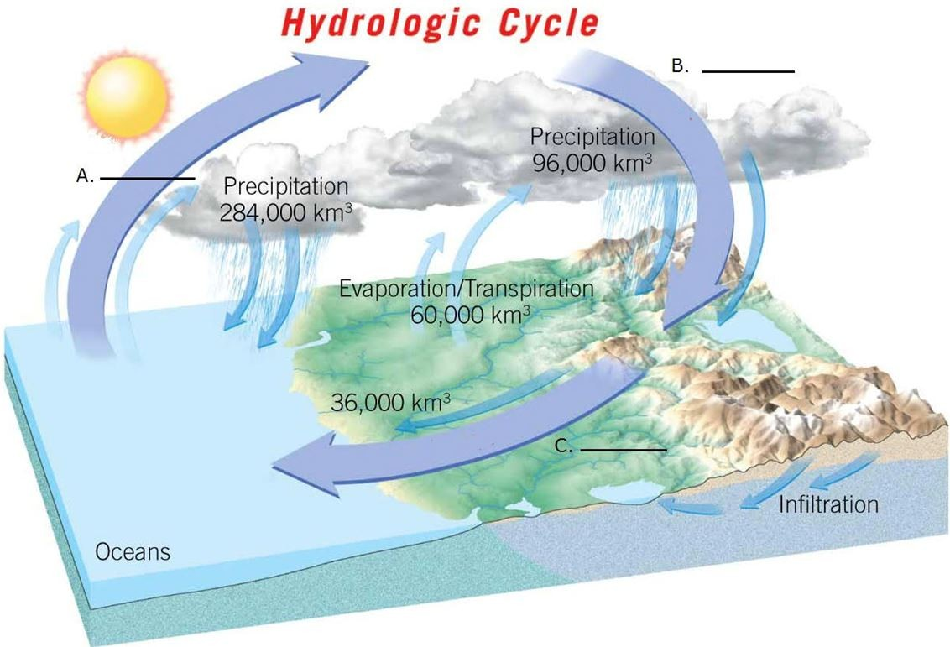

Use this image of the hydrologic cycle to illustrate the processes of the hydrologic sphere. Match the correct labels to the correct spaces for those processes.

A) Runoff
B) Precipitation
C) Evaporation

1) A
Diff: 1
Bloom's Taxonomy: Remembering/Understanding
Global Sci Out: 7
Section: 1.4 - Earth as a System
Focus/Concepts: 1.4
ESLI LO: 5.5 - Earth's water cycles among the reservoirs of the atmosphere, streams, lakes, ocean, glaciers, groundwater, and deep interior of the planet.
2) B
Diff: 1
Bloom's Taxonomy: Remembering/Understanding
Global Sci Out: 7
Section: 1.4 - Earth as a System
Focus/Concepts: 1.4
ESLI LO: 5.5 - Earth's water cycles among the reservoirs of the atmosphere, streams, lakes, ocean, glaciers, groundwater, and deep interior of the planet.

3) C
Diff: 1
Bloom's Taxonomy: Remembering/Understanding
Global Sci Out: 7
Section: 1.4 - Earth as a System
Focus/Concepts: 1.4
ESLI LO: 5.5 - Earth's water cycles among the reservoirs of the atmosphere, streams, lakes, ocean, glaciers, groundwater, and deep interior of the planet.

Answers: 1) C 2) B 3) A

Below is a partially completed geologic rock cycle. Using the choices provided, match the correct word with the correct blank in the rock cycle.

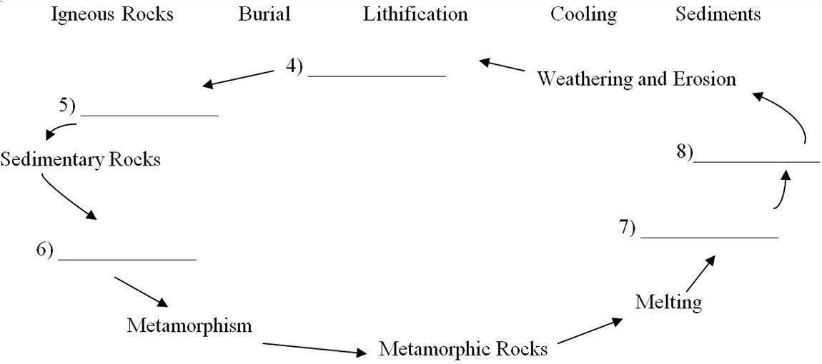
A) Cooling
B) Sediments
C) Igneous Rock
D) Lithification
E) Burial

4) 4
Diff: 1
Bloom's Taxonomy: Remembering/Understanding
Global Sci Out: 7
Section: 1.7 - Rocks and the Rock Cycle
Focus/Concepts: 1.7
ESLI LO: 4.6 - Earth materials take many different forms as they cycle through the geosphere.

5) 5
Diff: 1
Bloom's Taxonomy: Remembering/Understanding
Global Sci Out: 7
Section: 1.7 - Rocks and the Rock Cycle
Focus/Concepts: 1.7
ESLI LO: 4.6 - Earth materials take many different forms as they cycle through the geosphere.
6) 6
Diff: 1
Bloom's Taxonomy: Remembering/Understanding
Global Sci Out: 7
Section: 1.7 - Rocks and the Rock Cycle
Focus/Concepts: 1.7
ESLI LO: 4.6 - Earth materials take many different forms as they cycle through the geosphere.

7) 7
Diff: 1
Bloom's Taxonomy: Remembering/Understanding
Global Sci Out: 7
Section: 1.7 - Rocks and the Rock Cycle
Focus/Concepts: 1.7
ESLI LO: 4.6 - Earth materials take many different forms as they cycle through the geosphere.

8) 8
Diff: 1
Bloom's Taxonomy: Remembering/Understanding
Global Sci Out: 7
Section: 1.7 - Rocks and the Rock Cycle
Focus/Concepts: 1.7
ESLI LO: 4.6 - Earth materials take many different forms as they cycle through the geosphere.

Answers: 4) B 5) D 6) E 7) A 8) C

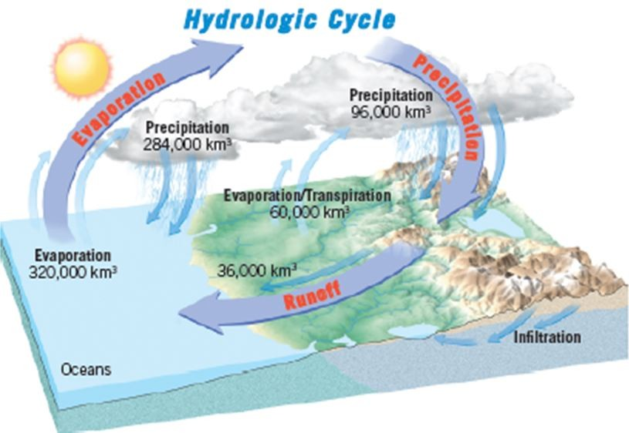

Using this diagram of the hydrologic cycle, identify three locations where the hydrologic sphere is interacting with one of the other three spheres. Match the correct labels to the correct spaces for those processes.

A) Atmospheric & Geologic Spheres
B) Hydrologic & Geologic Spheres
C) Hydrologic & Atmospheric Spheres

9) Next to the Evaporation arrow
Diff: 1
Bloom's Taxonomy: Remembering/Understanding
Global Sci Out: 2 & 7
Section: 1.4 - Earth as a System
Focus/Concepts: 1.4
ESLI LO: 4.1 - Earth's geosphere changes through geologic, hydrologic, physical, chemical, and biological processes that are explained by universal laws.
10) Next to the Precipitation arrow
Diff: 1
Bloom's Taxonomy: Remembering/Understanding
Global Sci Out: 2 & 7
Section: 1.4 - Earth as a System
Focus/Concepts: 1.4
ESLI LO: 4.1 - Earth's geosphere changes through geologic, hydrologic, physical, chemical, and biological processes that are explained by universal laws.

11) Next to the Runoff arrow
Diff: 1
Bloom's Taxonomy: Remembering/Understanding
Global Sci Out: 2 & 7
Section: 1.4 - Earth as a System
Focus/Concepts: 1.4
ESLI LO: 4.1 - Earth's geosphere changes through geologic, hydrologic, physical, chemical, and biological processes that are explained by universal laws.

Answers: 9) C 10) A 11) B

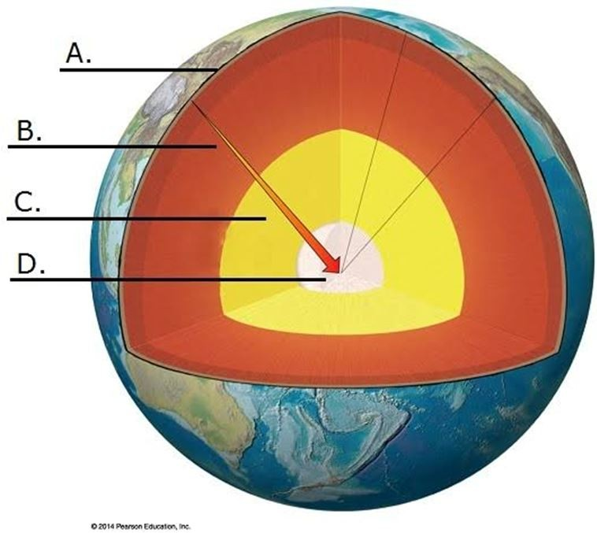

Using the blanks provided, match the correct labels to the parts of the interior of the Earth.

A) Mantle
B) Inner Core
C) Crust
D) Outer Core

12) A
Diff: 1
Bloom's Taxonomy: Remembering/Understanding
Global Sci Out: 7
Section: 1.6 - Earth's Internal Structure
Focus/Concepts: 1.6
ESLI LO: 2.3 - Earth was formed from the accumulation of dust and gas, and from multiple collisions of smaller planetary bodies.

13) B
Diff: 1
Bloom's Taxonomy: Remembering/Understanding
Global Sci Out: 7
Section: 1.6 - Earth's Internal Structure
Focus/Concepts: 1.6
ESLI LO: 2.3 - Earth was formed from the accumulation of dust and gas, and from multiple collisions of smaller planetary bodies.
14) C
Diff: 1
Bloom's Taxonomy: Remembering/Understanding
Global Sci Out: 7
Section: 1.6 - Earth's Internal Structure
Focus/Concepts: 1.6
ESLI LO: 2.3 - Earth was formed from the accumulation of dust and gas, and from multiple collisions of smaller planetary bodies.

15) D
Diff: 1
Bloom's Taxonomy: Remembering/Understanding
Global Sci Out: 7
Section: 1.6 - Earth's Internal Structure
Focus/Concepts: 1.6
ESLI LO: 2.3 - Earth was formed from the accumulation of dust and gas, and from multiple collisions of smaller planetary bodies.

Answers: 12) C 13) A 14) D 15) B

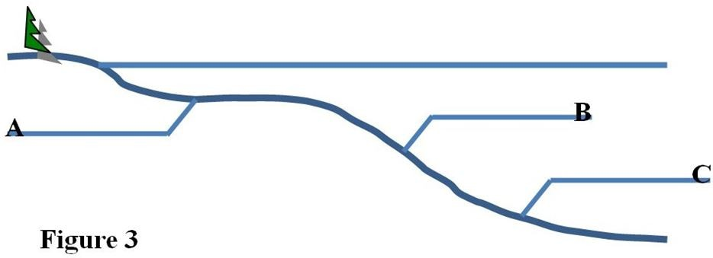

Label the correct parts of the seafloor for each blank in the image above.

A) Continental Shelf
B) Continental Rise
C) Continental Slope

16) A
Diff: 1
Bloom's Taxonomy: Remembering/Understanding
Global Sci Out: 3 & 7
Section: 1.8 - The Face of the Earth
Focus/Concepts: 1.8
ESLI LO: 3.1 - The four major systems of Earth are the geosphere, hydrosphere, atmosphere, and biosphere.

17) B
Diff: 1
Bloom's Taxonomy: Remembering/Understanding
Global Sci Out: 3 & 7
Section: 1.8 - The Face of the Earth
Focus/Concepts: 1.8
ESLI LO: 3.1 - The four major systems of Earth are the geosphere, hydrosphere, atmosphere, and biosphere.

18) C
Diff: 1
Bloom's Taxonomy: Remembering/Understanding
Global Sci Out: 3 & 7
Section: 1.8 - The Face of the Earth
Focus/Concepts: 1.8
ESLI LO: 3.1 - The four major systems of Earth are the geosphere, hydrosphere, atmosphere, and biosphere.

Answers: 16) A 17) C 18) B

